# What

Language learning website/App platform which will be used to help teachers and students by providing an online platform with information, content, lessons and resources that students can access to help them succeed in developing their Maori language skills, and teachers can utilise to help guide their students on their path to success.

# Mission

The purpose is to provide the user with a platform that will help them succeed in their studies by providing an easy to navigate website or web app, that provides students with explanations, of language structures, exercises in which they can practise using the structures and then a platform to write and create their own sentences.

# Goals

Initial:

* To be able to develop the basic language skills of the user and help prepare them for an upcoming assessment for either NCEA or Level 1 Language at Tertiary.
* To provide a foundation level language learning platform that will help in the revitalisation of Te Reo Māori

Short term:

* To provide a platform for students to be able to attain foundation level Maori language proficiency

Long term:

* To extend the platform to cater for intermediate level or even advanced proficiency in Te Reo Maori.
* To extend the learning to be iwi specific based around geographic locations and historic lineage.
* To provide a template for admin users and institutions to be able to alter the layout and or format of how the content is delivered based on their own individualised teaching plan and/or timetable.

# Intended Audiences

* Students or potential students
* General \public
* Secondary Schools
* Tertiary Providers
* Teachers

# Why will people come to your site?

Students will be able to log in, complete either the generic tasks or the tasks set by the teacher, review previous work and lessons or review other material that will help them on their language development journey. Something for the general public where they will be able to do some self-directed learning

# User experience

# Defining the audience

Although the intended audience is quite broad, there are 3 audiences that will be the primary focus of this project;

* Students who are studying either for NCEA or tertiary level academic achievement
* Teachers who will plan and guide the students on their journey.
* General public who might want to take a self-directed approach to their own learning

Students - Students who are studying for NCEA or tertiary level foundation Māori studies

Teachers - Giving teachers the ability to modify the timetable of each lesson (not the content) to suit their own individual teaching plan.

General Public – some people prefer a self-directed approach to their learning. Or would like to sample the program and decide whether they want to commit to the program or a program of learning

The interface needs to be easy to navigate. Material, easy to follow and the timetabling and planning platform that is easy to modify and fit for purpose.

# Competitive analysis

<https://kupu.maori.nz/> Is a similar website that has been developed to help learn basic foundations of Te Reo Māori. The website has some good content and reasonably easy interface.

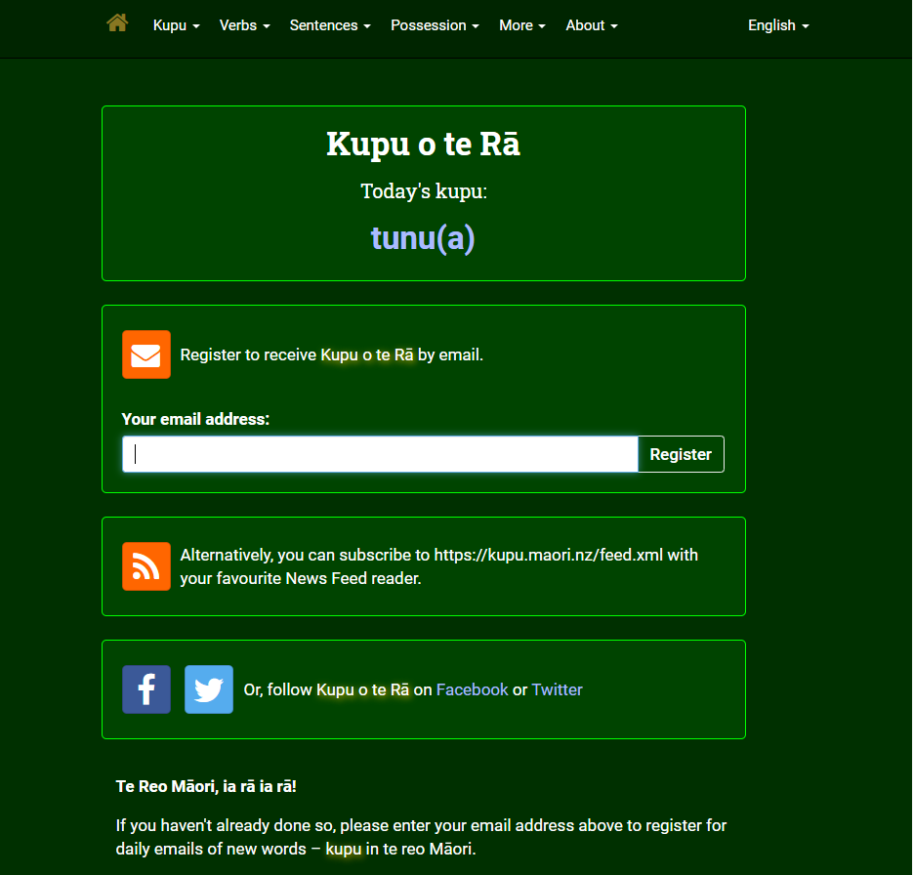



Content.

Herse a snippet of some content on the website. It looks at pronouns and is ordered into a table where the information is relatively easy to follow and the explanation is sufficient. The example help put the vocabulary into context thus exposing the user to new sentences and structures that they may not have been exposed to yet.

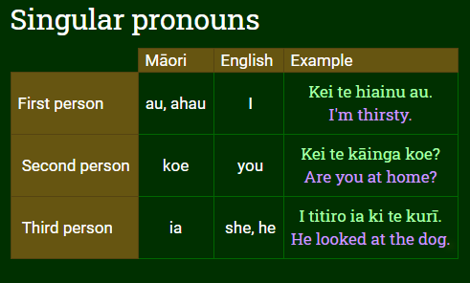

Potential Issues  
While the content is sound some of the vocabulary can be a bit of a distraction as it is quite complex with little explanation of more complicated language terms and features such as transitive verbs, stative verbs, relative clause. Some of these terms may intimidate or be a deterrent to the average learner who might not have a strong education background and may not be familiar these terms

|  |  |
| --- | --- |
|  |  |

# Site Content

Content and Functional requirements

* Main page/Home page
* Lessons
* Vocabulary Library
* Resources

Main Page/Home Page  
This page is the first thing that people will see when visiting the website so it needs to be warm inviting and easy to navigate. A react side bar to navigate the website will hopefully make the site more user friendly and keep people

Lessons  
The lessons pages will need to be structured and sequenced so that the information read is then put into practice with an activity that relates directly to the material presented.

Vocabulary Library  
The library will simply be a small compilation of about 1000 or so words that are relevant to all the lessons on the platform but are generic and commonly used within everyday communication. They will be organised appropriately nouns, verbs personal pronouns and even based on common topic that might be a focus etc. A section where the user can test themselves and their knowledge or vocabulary.

Resources  
The Resources will be links to useful content and other relevant websites that may be useful eg Maori Dictionary.com.

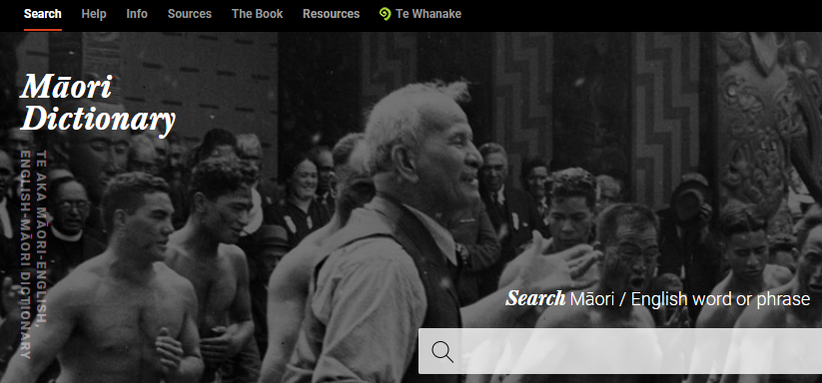

# What will I need?

A list of components that I can see will be required but am also prepared for more to be added as required down the track;

* Membership Database (long term vision)
  + Logins for both Users and Administrators with different functions depending on who is logging in
* Content repository
  + Grouping Labelling words part of Information Architecture Analysis (IAA)
* Lesson Layout and sequence.
  + Title
  + Explanation
  + Information/reading/Lesson Video
  + Relevant building block sentence structures to be added
  + Exercise
  + Playground (Somewhere for students to be able to play around with the structure that they’re learning)

# Conclusion

It is hoped that the content, structure and layout of this project will provide users with a simple and easy to navigate interface that will meet their learning needs while also giving them a more in-depth insight into things Māori. It is hoped that this will then lead to further study down the track and even to enrollment in other more advanced courses in the future.